**7.1.3. wkf_s_m_GPM_NOTIFICATION_PARTY_ELEC_ADDR_CDC**

**m_GPM_NOTIFICATION_PARTY_ELEC_ADDR_CDC**

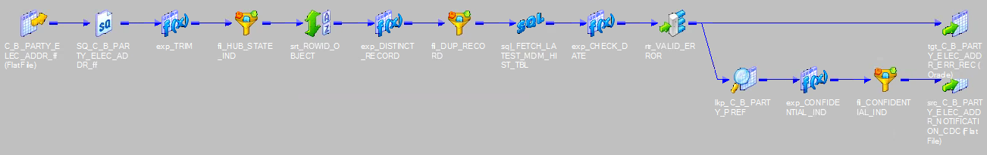

**m_GPM_NOTIFICATION_PARTY_ELEC_ADDR_CDC_WEB_SERVICE**

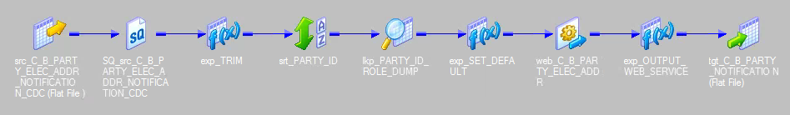

**7.1.3.1. Maestro Job Details**

|  |  |
| --- | --- |
| **Job Name** | BEMD_NOTIFICATON_PARTY_ELEC_ADDR_GPM3 |
| **File Landing Location** | /work/infshared/GPM/Strategic/Source/NOTIFICATION/Inbound |
| **Data File Name** | CDC_PARTY_ELEC_ADDR.TXT |
| **Trigger File Name** | CDC_NOTIFICATION.TRG |

**7.1.3.2. Power Center Workflow Properties**

|  |  |
| --- | --- |
| **Workflow Name** | wkf_s_m_GPM_NOTIFICATION_PARTY_ELEC_ADDR_CDC |
| **Session Name** | s_m_GPM_NOTIFICATION_PARTY_ELEC_ADDR_CDC s_m_GPM_NOTIFICATION_PARTY_ELEC_ADDR_CDC_WEB_SERVICE |
| **Parameter File Path and Name** | /work/infshared/GPM/Strategic/Paramfile/NOTIFICATION/  wkf_s_m_GPM_NOTIFICATION_ELEC_ADDR_CDC.prm |

**7.1.3.3. Mapping Specific Transformations**

1. **m_GPM_NOTIFICATION_PARTY_ELEC_ADDR_CDC**

Following mapping specific transformations are needed in the Power center mapping. It may be changed/ modified later on based on the requirement change.

## SOURCE QUALIFIER

|  |  |
| --- | --- |
| **Transformation Name** | SQ_C_B_PARTY_ELEC_ADDR_ff |
| **Transformation Type** | Source Qualifier |
| **Transformation Description** | The Party Elec Addr CDC file received from BigData is sourced. |

## EXPRESSION TRANSFORMATION

|  |  |
| --- | --- |
| **Transformation Name** | exp_TRIM |
| **Transformation Type** | Expression |
| **Transformation Description** | Used to remove trailing spaces from either side of records.  **LTRIM**(**RTRIM**(ROWID_OBJECT)) |

## FILTER TRANSFORMATION

|  |  |
| --- | --- |
| **Transformation Name** | fil_HUB_STATE_IND |
| **Transformation Type** | Filter |
| **Transformation Description** |  |

## SORTER TRANSFORMATION

|  |  |
| --- | --- |
| **Transformation Name** | srt_ROWID_OBJECT |
| **Transformation Type** | Sorter |
| **Transformation Description** | The ROWID_OBJECT attributed is sorted. |

## EXPRESSION TRANSFORMATION

|  |  |
| --- | --- |
| **Transformation Name** | exp_DISTINCT_RECORD |
| **Transformation Type** | Expression |
| **Transformation Description** |  |

## FILTER TRANSFORMATION

|  |  |
| --- | --- |
| **Transformation Name** | fil_DUP_RECORD |
| **Transformation Type** | Filter |
| **Transformation Description** |  |

## SQL TRANSFORMATION

|  |  |
| --- | --- |
| **Transformation Name** | sql_FETCH_LATEST_MDM_HIST_TBL |
| **Transformation Type** | SQL Transformation |
| **Transformation Description** | The ROWID_OBJECT information is used to refer to the MDM Hist table: C_B_PARTY_ELEC_ADDR_HIST to fetch the last updated record. |

## EXPRESSION TRANSFORMATION

|  |  |
| --- | --- |
| **Transformation Name** | exp_CHECK_DATE |
| **Transformation Type** | Expression |
| **Transformation Description** |  |

## ROUTER TRANSFORMATION

|  |  |
| --- | --- |
| **Transformation Name** | rtr_VALID_ERROR |
| **Transformation Type** | Router |
| **Transformation Description** |  |

#### LOOKUP TRANSFORMATION

|  |  |
| --- | --- |
| **Transformation Name** | lkp_C_B_PARTY_PREF |
| **Transformation Type** | Lookup |
| **Transformation Description** | The look up is done on C_B_PARTY_PREF table to fetch PREF_TP(as Confidential or DoNotSolicit) |

## EXPRESSION TRANSFORMATION

|  |  |
| --- | --- |
| **Transformation Name** | exp_CONFIDENTIAL_IND |
| **Transformation Type** | Expression |
| **Transformation Description** | A flag is created. All the active records with PREF_TP as confidential/DoNotSolicit is set as ‘Y’ ,otherwise, ‘N’ is set. |

## FILTER TRANSFORMATION

|  |  |
| --- | --- |
| **Transformation Name** | fil_CONFIDENTIAL_IND |
| **Transformation Type** | Filter |
| **Transformation Description** |  |

#### TARGET TRANSFORMATION

|  |  |
| --- | --- |
| **Transformation Name** | tgt_C_B_PARTY_ELEC_ADDR_NOTIFICATION_CDC |
| **Transformation Type** | Target Transformation |
| **Transformation Description** | The records are dumped into a flat-file |

1. **TARGET TRANSFORMATION**

|  |  |
| --- | --- |
| **Transformation Name** | src_C_B_PARTY_ELEC_ADDR_NOTIFICATION_CDC |
| **Transformation Type** | Target Transformation |
| **Transformation Description** | The records are dumped into a flat-file |

1. **m_GPM_NOTIFICATION_PARTY_ELEC_ADDR_CDC_WEB_SERVICE**

Following mapping specific transformations are needed in the Power center mapping. It may be changed/ modified later on based on the requirement change.

#### A. SOURCE QUALIFIER

|  |  |
| --- | --- |
| **Transformation Name** | SQ_src_C_B_PARTY_ELEC_ADDR_NOTIFICATION_CDC |
| **Transformation Type** | Source Qualifier |
| **Transformation Description** | The target dump created in the previous mapping is used as source. |

#### 

#### B . EXPRESSION TRANSFORMATION

|  |  |
| --- | --- |
| **Transformation Name** | exp_TRIM |
| **Transformation Type** | Expression |
| **Transformation Description** |  |

## C.SORTER TRANSFORMATION

|  |  |
| --- | --- |
| **Transformation Name** | srt_PARTY_ID |
| **Transformation Type** | Sorter |
| **Transformation Description** |  |

## D. LOOKUP TRANSFORMATION

|  |  |
| --- | --- |
| **Transformation Name** | lkp_PARTY_ID_ROLE_DUMP |
| **Transformation Type** | Lookup |
| **Transformation Description** |  |

#### E . EXPRESSION TRANSFORMATION

|  |  |
| --- | --- |
| **Transformation Name** | exp_SET_DEFAULT |
| **Transformation Type** | Expression |
| **Transformation Description** | The mandatory fields are parameterized and passed further. |

#### F. WEB SERVICE CONSUMER TRANSFORMATION

|  |  |
| --- | --- |
| **Transformation Name** | web_C_B_PARTY_ELEC_ADDR |
| **Transformation Type** | Web service consumer transformation |
| **Transformation Description** | The files are transformed into a SOAP message and GPM Notification web service is called for each row in the file |

#### G. EXPRESSION TRANSFORMATION

|  |  |
| --- | --- |
| **Transformation Name** | exp_OUTPUT_WEB_SERVICE |
| **Transformation Type** | Expression |
| **Transformation Description** | The concatenated output of the Web service consumer transformation is directed to the target through this expression. |

#### H. TARGET TRANSFORMATION

|  |  |
| --- | --- |
| **Transformation Name** | tgt_C_B_PARTY_NOTIFICATION |
| **Transformation Type** | Target Transformation |
| **Transformation Description** | All records are loaded into tgt_C_B_PARTY_NOTIFICATION flat-file. |

**7.1.3.4. PARAMETER DETAILS**

|  |  |  |
| --- | --- | --- |
| **Type** | **Name** | **Value** |
| Mapping Parameter | $$USERNAME | gpm3srvcsid_d |
| $$PASSWORD | metlife1 |
| $$ENTITYUPDATE | CONTACT |
| $$APPID | CCIANI |
| $$SOURCE | ML |
| $$ETL | ETL |